**Physical Chemistry 2 DFT Lab**

**Quantum Espresso Files**

You will notice that each subdirectory contains at least one (1) file designated with the .in extension. This is the input file that Quantum Espresso looks for, containing all the requisite input parameters needed to run a DFT calculation.

**Linux Tutorial**

Linux systems are prompt based **and is cap sensitive.** This tutorial will explain the basic commands needed to navigate between directories, make new files/directories, copy/rename/delete files, use an editor, and execute commands.

List of common Linux commands and their usage

|  |  |
| --- | --- |
| **Command** | **Usage** |
| pwd | list current directory |
| mkdir *directory* | create a directory by name *directory* |
| rmdir *directory* | deletes *directory* |
| cd *directory* | change to directory *directory* |
| cd .. | go back one directory |
| ls | list all the files in the current directory |
| cp *file1* *file2* | make a copy of *file1* and name it *file2* |
| mv *file1* *file2* | rename *file1* to *file2* |
| rm *file1* | delete *file1* |
| **Using directories for cp, mv** |  |
| cp *file1 ./directory/.* | copy *file1* into *directory* (name stays the same) |
| mv *file1 ./directory/.* | move *file1* into *directory* |
| cp *file1 ./directory/file2* | copy *file1* into *directory* and name *file2* |
| * | wildcard- can be used with ls, cp, mv, and rm |
| ps | shows your current jobs |
| top | shows usage of the machine |
| kill *jobID* | terminates a process of *jobID* |
| Ctrl C | terminates a job |
| Ctrl Z | suspends a job |
| & | runs process in background |
| cat *file1 file2* | concatenate *file1* and *file2* |
| > *file1* | write output to *file1* |
| **Editor** |  |
| emacs | opens editor |
| emacs *file1* | opens file1 in editor (if file doesn’t exist, file is blank) |
| Ctrl X Ctrl S | to save |
| Ctrl Z | to exit from editor |

**Exercise 1**: Calculate the equilibrium bond length of the Cl2 dimer molecule.

* Make sure you have the file cl2.in by issuing the command ls.
* Open this file (say by using the emacs editor typing “emacs cl2.in”; learn to use this editor). The file should look like this:

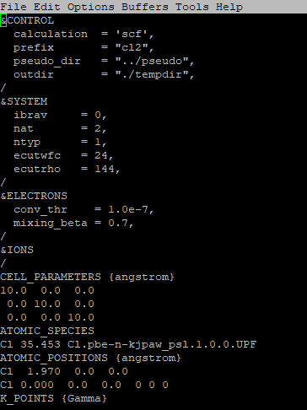

**Figure 1:** Emacs window showing the input parameters for cl2.in, used to calculate the equilibrium bond length of Cl2 dimer molecule.

Important input parameters are segmented by category with input cards, denoted by the ampersand (&) prefix

* CONTROL: Controls calculation type as well as input/output to disk and screen
* SYSTEM: Input parameters that specify the type of system under study, including the unit cell as well as the energy and density cutoff.
* ELECTRONS: Controls the algorithms used to reach self-consistent solutions to the Kohn-Sham equations
* IONS: Controls ionic motion
* ATOMIC_SPECIES: Name, mass, and pseudopotential used for each atomic species present in the system
* ATOMIC_POSITIONS: Type and coordinates of each atom in the unit cell
* K_POINTS: Coordinates and weights of the k-points used for reciprocal space integration.
* CELL_PARAMETERS: Components of the three lattice vectors of the system (i.e. supercell); needed when ibrav=0.

Regardless of whether an atom, a molecule, a periodic or a non-periodic solid is under investigation, Quantum Espresso will place the system in a “supercell” that will repeat in 3-dimensional space. For this problem, since we want to study a Cl2 dimer, we would like to place the molecule in a large box so that the dimer does not “see” its periodic image. A rule of thumb is that a distance of about 8 Å between one end of a system and the nearest end of its periodic image is sufficient to ensure isolation; hence the choice of 10 Å for each of the lattice vectors.

We can use Quantum Espresso to calculate the total energy of this system as a function of the bond length, from which the equilibrium bond length can be determined. To do a Quantum Espresso calculation for a given input file, type:

[userid@node5 ~]$/opt/qe-7.2/bin/pw.x < cl2.in > results.out &

This will run the program pw.x which will take as input cl2.in and print the output of the calculations to the file results.out rather than the screen. This calculation should take little time (~1 min maximum). We want to see what the total energy is for this particular configuration (i.e. Cl2 dimer at a bond length of 1.97 Å). Open results.out and make your way to the bottom of the file. You should find the following line:

! total energy = -158.63873587 Ry

Record the bond length and value in an external table (i.e. Excel will do).

Now edit cl2.in and change the x-coordinate of the second Cl to 1.99, save the file, exit the editor, and redo the Quantum Espresso calculation by issuing the command above. Change the output file name if you want to keep the results from separate runs. Record the total energy for this case as you did for 1.97 Å run. Repeat the calculation for successive increases of the bond length up to 2.07 Å. Below is a table of the bond length (in Å) versus the total energy (in Ry).

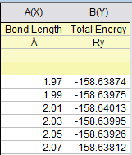

**Figure 2:** Data table of the bond length (in Å) versus the total energy (in Ry) for Cl2 dimer.

A plot of total energy versus bond length yields a parabola with a minimum at 2.02 Å. The experimental value for the Cl2 equilibrium bond length is 2.01 Å

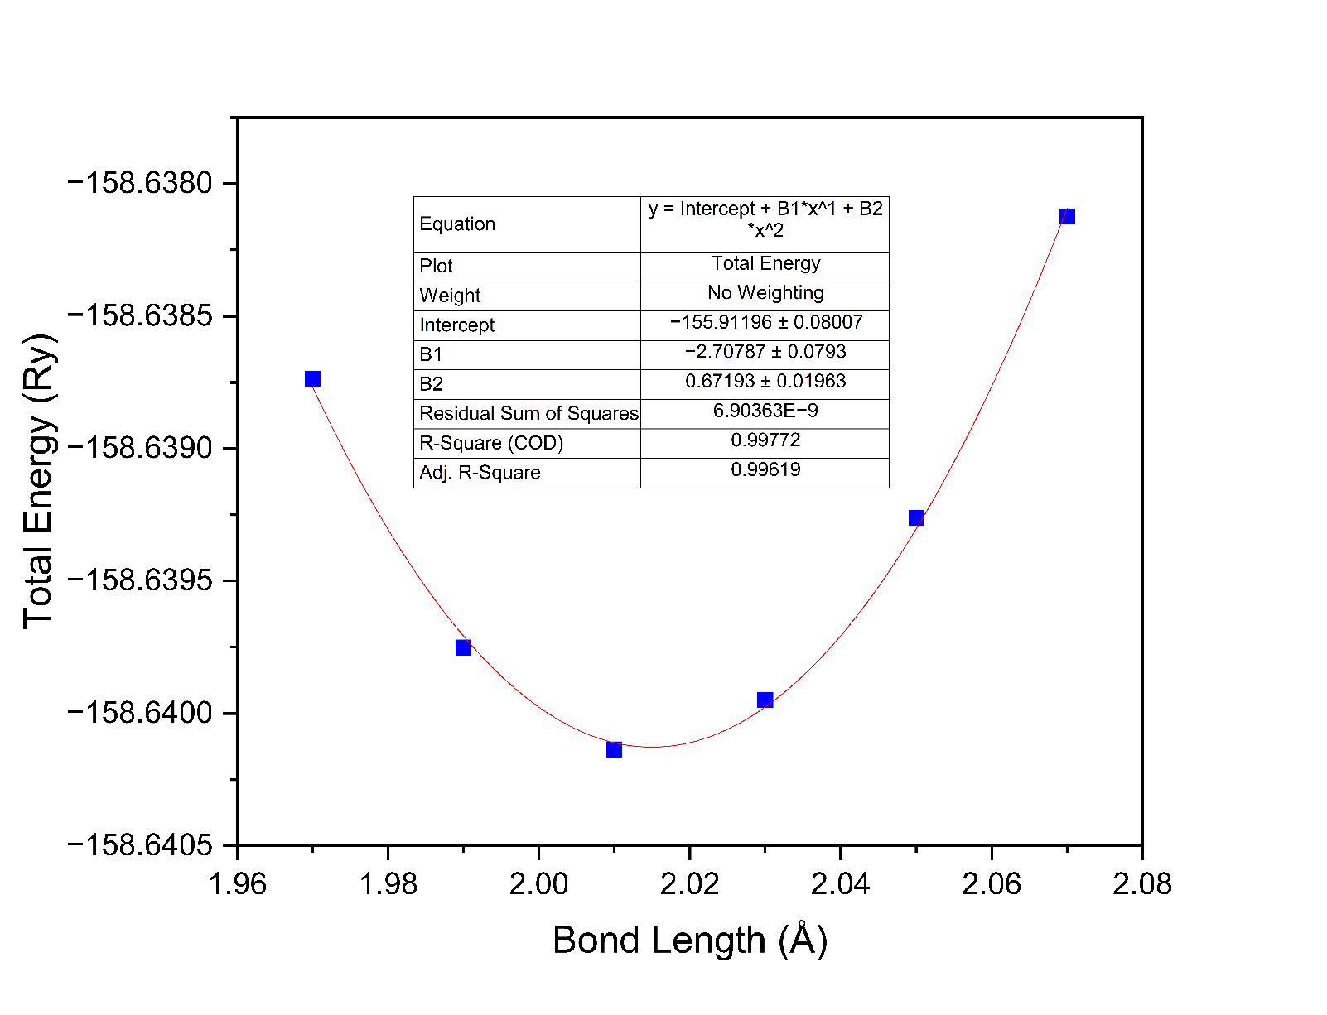

**Figure 3:** Plot of the bond length (in Å) versus the total energy (in Ry) as well as a parabolic equation of best fit for Cl2 dimer.

**Exercise 1b**: Calculate the equilibrium bond length of the H2 dimer molecule. [Experimental value of the bond length is 0.74 Å]

**Exercise 1c**: Calculate the equilibrium bond length of the F2 dimer molecule. [Experimental value of the bond length is 1.41 Å]

**Exercise 1d**: Calculate the equilibrium bond length of the O2 dimer molecule. [Experimental value of the bond length is 1.21 Å]. Look at o2.in. What is the nspin flag and why do we need to use it in this calculation?

**REPEAT FOR H2 DIMER (REMEMBER TO ADJUST TO FIND THEORETICAL H2 Length)**

**Exercise 2**: Calculate the band structure of Silicon

(walkthrough)